6.4 Solutions to Linear Systems Using Matrices

What is a Matrix?
A matrix is a rectangular array of elements.

The dimension of a matrix is m × n (m by n) if it has m rows and n columns. A square matrix has the same number of rows and columns. Matrices are frequently used to represent systems of linear equations.

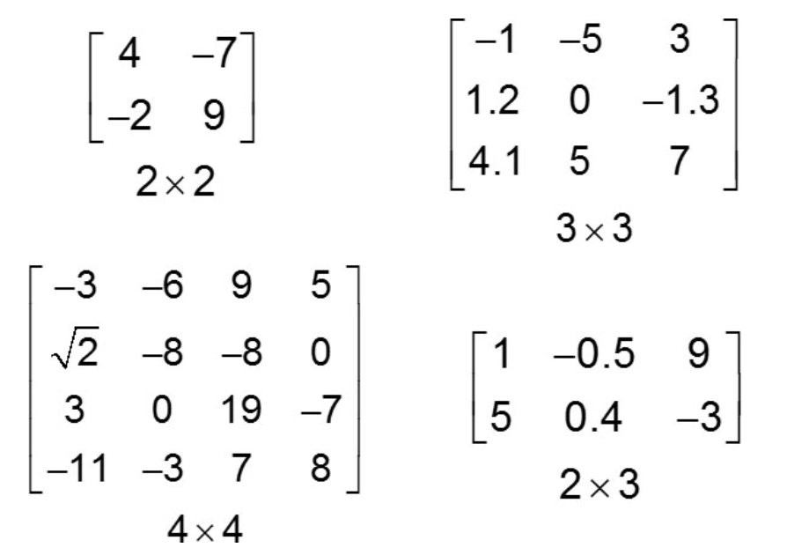

Try It Yourself: Give an example of a 4x1 matrix.

Representing a Linear System with an Augmented Matrix

An augmented matrix is a matrix that represents a system of linear equations. It combines the coefficients of the variables from the system of equations along with the constants from the right-hand side of each equation, all in a single matrix.

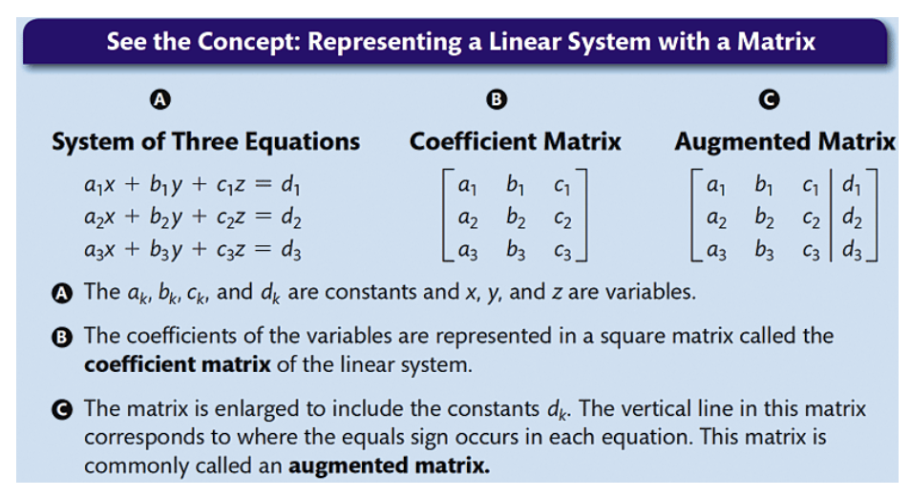

Example. Representing a Linear System with an Augmented Matrix
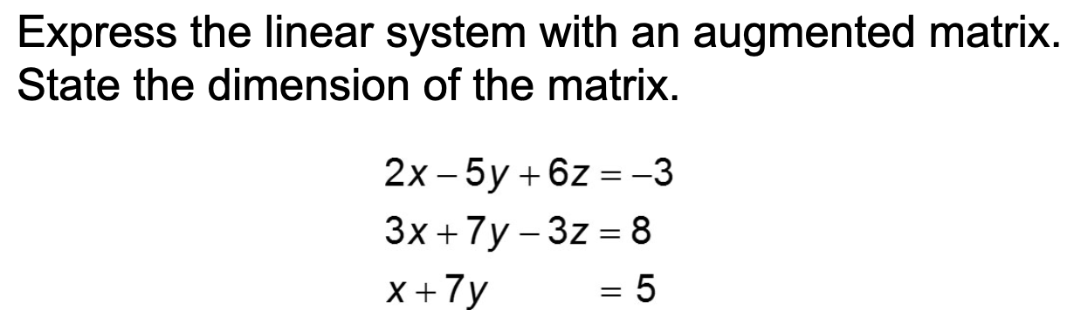

Row Echelon Form

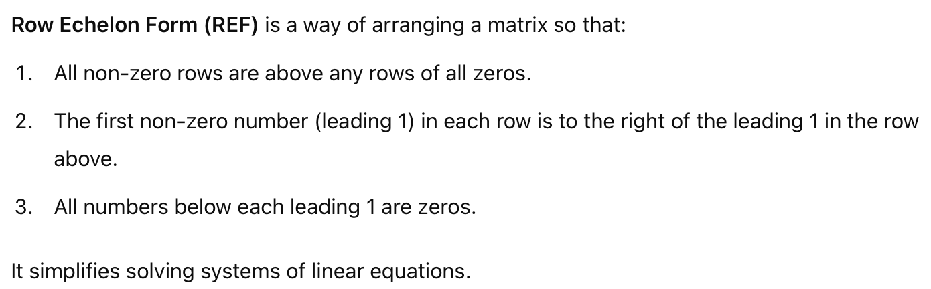

Examples. The following are in REF.

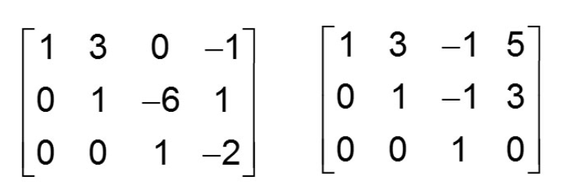

Example. Solving a System when its Row Echelon Form is Given.

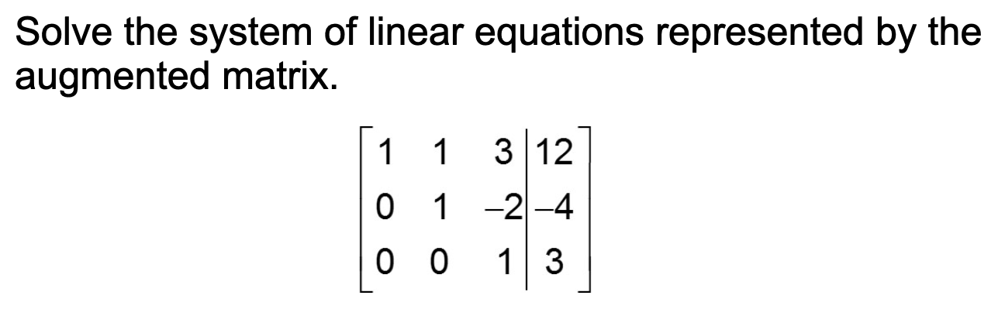

Reduced Row Echelon Form

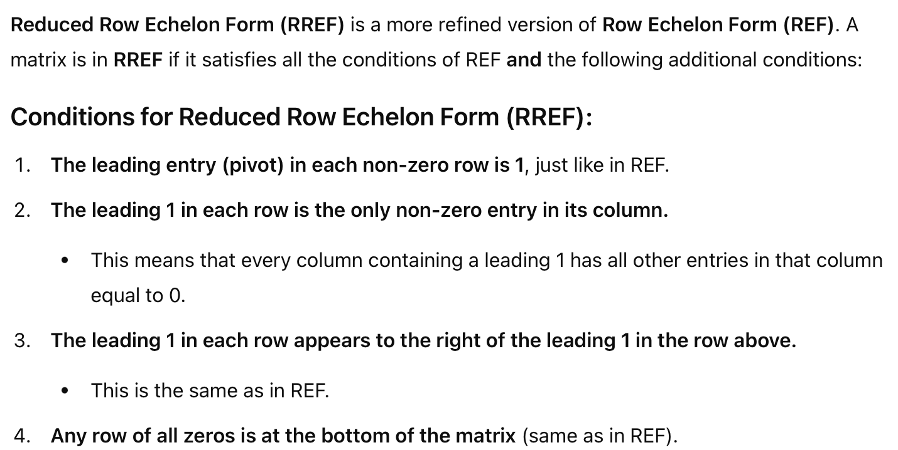

Example. Reading the solution from the RREF.

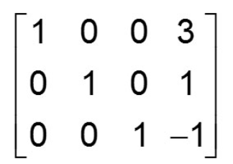

Geometric Interpretation

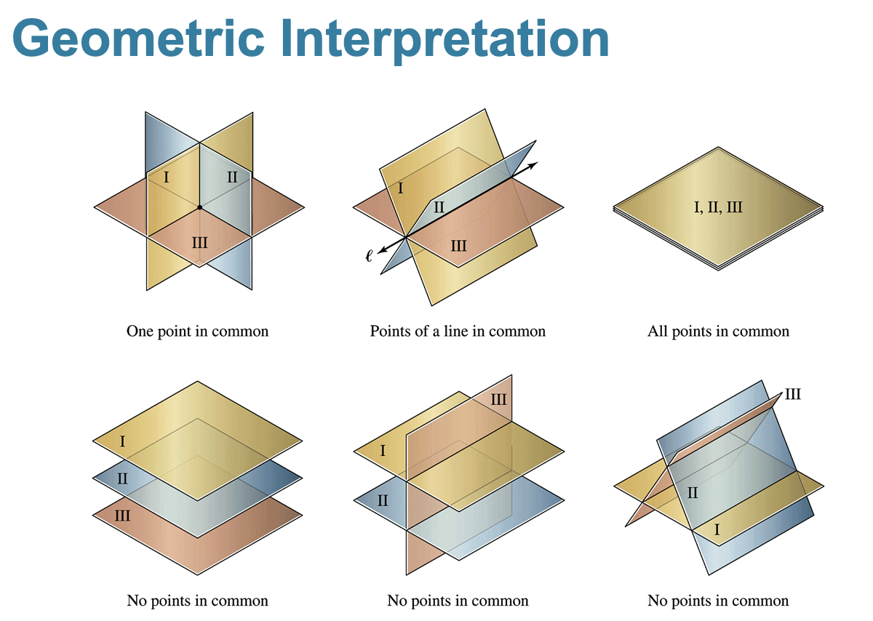

Example. Solving a System in Three Variables Using Your Calculator.

